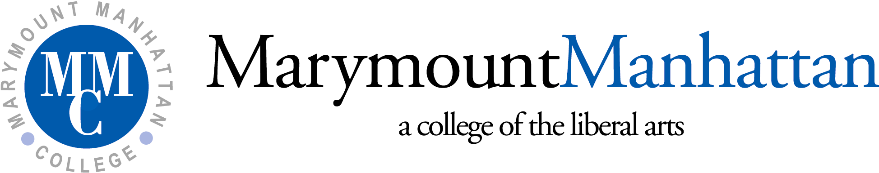

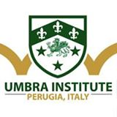

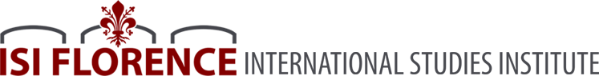

Marymount Manhattan College Study Abroad Programs
In Partnership With
The International Studies Institute (Florence, Italy)
The Umbra Institute (Perugia, Italy)

Dear Student,

We are excited that you are interested in MMC’s study abroad programs through our parterships with the International Studies Institute (ISI) in Florence, Italy and the Umbra Institute, in Perugia, Italy. Both schools specialize exclusively on study abroad programs for American students, offering high-quality academic programs and outstanding co-curricular and extra-curricular activities. Faculty at both schools are scholars in their respecitive fields and the staff work tirelessly to ensure that you have a positive study abroad experience. And because MMC has direct partnerships with both schools, the application process is streamlined as faculty and staff at MMC and both ISI and the Umbra Institute work collaboratively to offer you guidance and support from your initial application to your return to the United States following your study abroad program.

Step one of the application process is to complete the attached MMC Application Form and to have a preliminary meeting with an advisor in the Academic Advisement Office. When you have completed the application, you can return it to Cindy Sittler. Once it has been reviewed by Cindy Sittler and approved by Dr. Peter Naccarato, the Faculty Liaison to the ISI and the Umbra Institute, you will receive an e-mail indicating that you can go ahead and complete the on-line application for the school that you have selected (ISI or the Umbra Institute). Note the following deadlines for submitting the MMC Application Form:

- October 1 for spring semester study abroad program
- April 1 for summer, fall, and full academic year study abroad program

Of course, feel free to reach out to us as you work on your application. We are happy to answer any questions and to provide any additional information.

Best,

Peter Naccarato, Ph.D. Cindy Sittler
MMC Faculty Liaison to the ISI and the Umbra Institute Study Abroad Coordinator
pnaccarato@mmm.edu csittler@mmm.edu
(646)-393-4110 (212)-774-0791

INTERNATIONAL STUDIES INSTITUTE & UMBRA INSTITUTE
STUDY ABROAD APPLICATION
For MMC Matriculated Students only
INSTRUCTIONS: After completing this form, return it to Cindy Sittler, Study Abroad Coordinator.
Applicant Personal Information
Name:
MMC ID:
Date of Birth: _______________________________________________
Permanent Address: ___________________________________________________________
Local Address (if different): _____________________________________________________
Cell Phone: _________________________ Home Phone:_____________________________
Applicant Academic Information
Degree/Major:
Minor, if applicable:
Study Abroad Program Information

❑ International Studies Institute (Florence, Italy)

❑ Umbra Institute (Perugia, Italy)

❑ General Studies Program
❑ Universita di Perugia Program (Italian fluency required)
❑ Universita di Stranieri Program (focus on Italian language and culture)

Proposed Study Abroad Term (Select one):
❑ Fall 20____ ❑ Spring 20____ ❑ Summer 20____ ❑ Full Academic Year ____

Deadlines for submitting the MMC Application Form:

- October 1 for spring semester study abroad program
- April 1 for summer, fall, and full academic year study abroad program

Marymount Manhattan College Study Abroad Programs
The International Studies Institute (Florence, Italy)
The Umbra Institute (Perugia, Italy)

CHECKLIST

PART I: Study Abroad Coordinator

Yes No
❑ ❑ The student has a cumulative GPA of at least 2.8 at MMC.
❑ ❑ The student has satisfied all past and current financial obligations to the College.
❑ ❑ The student has completed a minimum of 12 credits (one full semester) at MMC.
❑ ❑ The student has declared a major.
❑ ❑ The student has a passport that is valid for 6 months after the end of his/her proposed period
of study.
❑ ❑ The student meets all of the eligibility requirements for study abroad at either the International
Studies Institute or the Umbra Institute.

The following materials have been submitted to the Study Abroad Coordinator and are being forwarded to the Faculty Liaison for review:

❑ Completed Application
❑ Completed Personal Statement
❑ Completed Faculty Recommendation

__________________________________________ ___________
Signature of Study Abroad Coordinator Date

PART II: Academic Advisor

❑ I have met with the student to review his/her study abroad plans.

__________________________________________ ___________
Signature of Academic Advisor Date

PART III: Student

❑ I have completed the application
❑ I have met with an advisor in the Office of Academic Advisement
❑ I have attached the required personal statement or sent it via e-mail to Cindy Sittler
❑ I have requested a faculty letter of recommendation from: ________________________________________

__________________________________________ ___________
Signature of Student Date

Personal Statement

Write a concise statement (maximum 500 words) that addresses the following:
- What is your proposed program of study and how does it relate to your present academic program and/or professional goals?
- What personal attributes and/or experiences do you believe have prepared you to live and study abroad?
- What concerns, if any, do you have about living and studying abroad?
- Feel free to include any additional information that may be useful in evaluating your candidacy.

Please either print your personal statement and return it with your application or e-mail it to Cindy Sittler (csittler@mmm.edu) as a Microsoft Word attachment.

Faculty Letter of Recommendation

As part of your application, you need to submit a faculty recommendation from either a faculty member who has had you as a student or your faculty academic advisor.

Please give the attached Recommendation Form to your faculty recommender and ask him/her to return it to Cindy Sittler, who will confirm with the faculty member and you when she has received it.

MarymountManhattan College Study Abroad Programs
In Partnership With
The International Studies Institute (Florence, Italy)
The Umbra Institute (Perugia, Italy)

Confidential Faculty Recommendation Form

To be completed by the student:

Name: ______________________________________________

MMC ID: ___________________________________________

Major(s): _____________________________ Minor(s): ________________________________

Proposed Study Abroad Program:

❑ International Studies Institute (Florence, Italy)
❑ Umbra Institute (Perugia, Italy)

Proposed Study Abroad Term (Select one):
❑ Fall 20____ ❑ Spring 20____ ❑ Summer 20____ ❑ Full Academic Year ____

Waiver of Access:

Under the provision of the Family Educational Rights and Privacy Act of 1974, I waive my right of access to this evaluation, and I understand that this evaluation will be used only for the purpose for which it was prepared.

Please circle one: Yes No

_______________________________________________________ ____________
Signature Date

To be completed by the faculty member:

The above-named student is applying to study with one of MMC’s partners, the International Studies Institute in Florence, Italy or the Umbra Institute in Perugia, Italy. Please offer your confidential answers to the following questions, which will help us determine the student’s preparedness for this study abroad experience.

After completing the recommendation, you can return a printed version to Cindy Sittler or e-mail it to her (csittler@mmm.edu) as a Microsoft Word attachment.

1) How long have your known this student and in what capacity/capacities?

2) Please offer your assessment of the student’s abilities in each of the following areas:

Excellent Good Average Poor Unable to evaluate

Academic ability ❑ ❑ ❑ ❑ ❑
Academic interest and motivation ❑ ❑ ❑ ❑ ❑
Capacity for independent study ❑ ❑ ❑ ❑ ❑
Ability to express thoughts in class ❑ ❑ ❑ ❑ ❑
Ability to express thoughts in writing ❑ ❑ ❑ ❑ ❑
Reliability ❑ ❑ ❑ ❑ ❑
Emotional stability ❑ ❑ ❑ ❑ ❑
Ability to relate well to others ❑ ❑ ❑ ❑ ❑
Likelihood of success in study abroad ❑ ❑ ❑ ❑ ❑

3) Please offer your opinion of the student’s level of preparation (both academically and non-academically) for this study abroad experience. What do you believe to be the student’s most important strengths that you believe will propel her/him to success in this study abroad experience? What concerns, if any, do you have about the student’s ability to succeed in this program?

Faculty Recommender’s Name: ________________________________________________________

Faculty Recommender’s Department: ___________________________________________________

Faculty Recommender’s Signature: _____________________________________________________

Date: _________________

